April 2018

Prepared by John F. Filicetti, PMP, MBA

Intended Audience 1

Capability Maturity Model (CMM) Overview 2

Capability Maturity Model Progression 2

How to Facilitate CMM Progression 3

Level 1 – Ad-Hoc 3

Level 2 – Repeatable 3

Level 3 – Defined 4

Level 4 – Managed 4

Level 5 – Optimized 4

Summary 4

**Abstract**

The Capability Maturity Model (CMM) is a widely accepted set of guidelines for developing high-performance software organizations. It can be applied to organizations and processes other than software development. This white paper takes a close look at the Capability Maturity Model and how your organization can progress through the levels of the CMM.

# Intended Audience

This document is primarily intended for managers at all levels and any organization attempting process improvement.

# Capability Maturity Model (CMM) Overview

**Improving results through process improvement**

The Capability Maturity Model® (CMM®) for software maintained by the Software Engineering Institute (SEI) is a widely accepted set of guidelines for developing high-performance organizations; specifically, SW-CMM® Capability Maturity Model for Software, P-CMM People Capability Maturity Model, SA-CMM Software Acquisition Capability Maturity Model, SE-CMM Systems Engineering Capability Maturity Model, and IPD-CMM Integrated Product Development Capability Maturity Model. The original concept for the CMM was developed by Watts Humphrey and his colleagues at IBM in the early 1980s. Humphrey determined the quality of an application was related directly to the quality of the process used to develop it. To improve application development (AD) processes, Humphrey wanted to implement the W. E. Deming’s continuous-improvement cycle (i.e., plan – do – check – act); however, application developers had been installing improved development methods and technologies for a decade without gaining much improvement.

Humphrey observed improved AD practices did not endure unless an AD organization’s behavior changed to sustain them. He also found AD organizations had to remove obstacles to continuous improvement in a specific order if they were to succeed. Consequently, Humphrey designed the process maturity framework, an evolutionary path to help AD organizations increase the capability of their AD processes in five stages (see Figure 1).

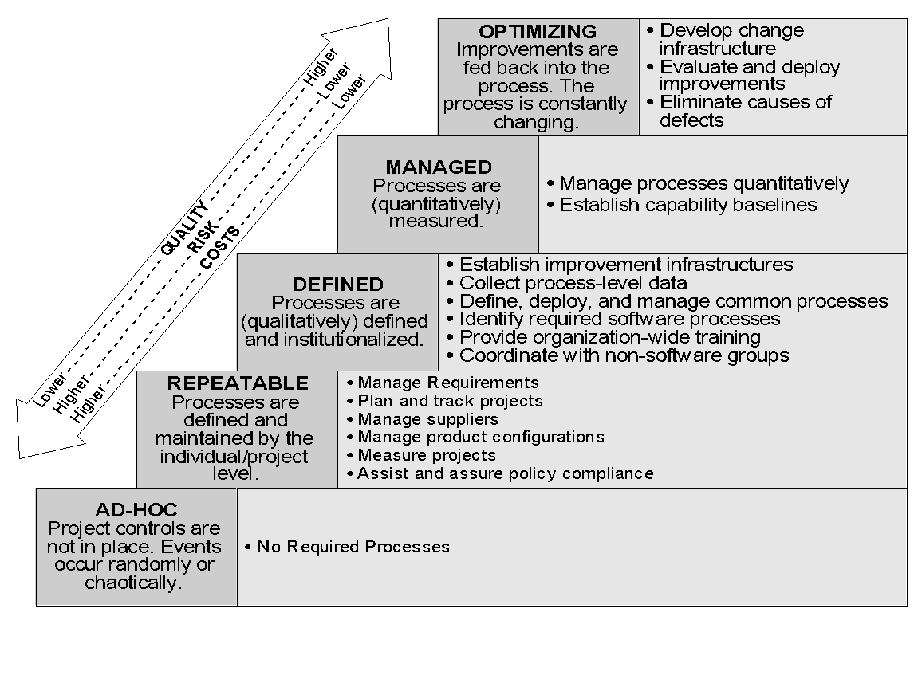

Figure 1 - Levels of the Capability Maturity Model

# Capability Maturity Model Progression

When organizations apply effort to advance from one level through the next throughout the five maturity levels, their practices are transformed from an undisciplined, ad-hoc state into disciplined, consistent processes capable of predictable and repeatable results and its culture is also transformed by the evolutionary process. The Capability Maturity Model (CMM) is a roadmap of organizational development and change. Each maturity level is characterized by the implementation and institutionalization of several practices and the clusters of practices contributing to the development capability achieved at that level (see Figure 2). An evolution from one level to the next can take a tremendous amount of focused energy by the organization and years to achieve.

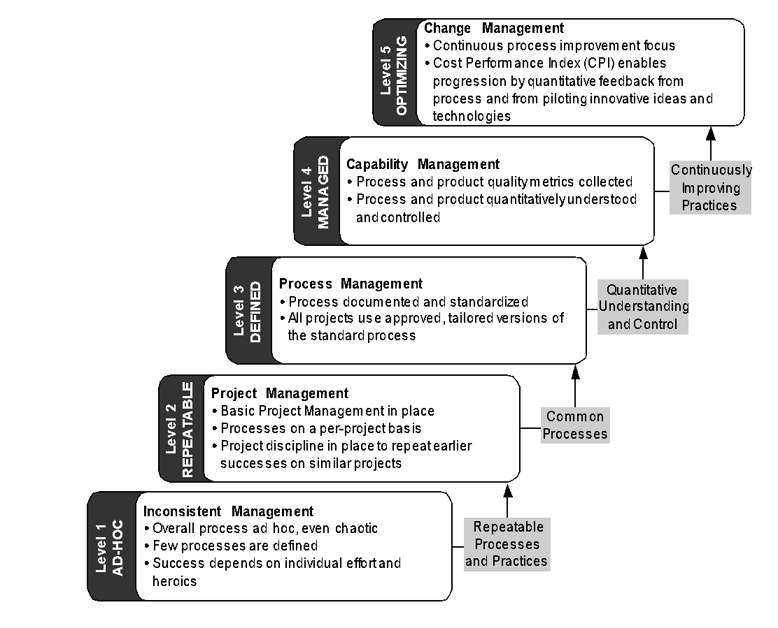

Figure 2 - Progression through the CMM Levels

# How to Facilitate CMM Progression

## Level 1 – Ad-Hoc

At the Ad-Hoc level, the practices and results of the organization are inconsistent and uncoordinated. There is not time to define the processes because the organization is expending so much effort to meet project deadlines and produce project deliverables. Any deadlines met are done through individual heroics and with little consistency.

Project management at this level is usually weak and excessive changes are common due to unreasonable commitments and requirements definition. Finding and utilizing a collaborative project management solution can assist the organization trying to advance from level 1 to level 2 by providing an environment to define the corporate process from successful projects, capturing lessons learned and best practices. As the process is defined and outlined in a project schedule, the organization can repeat these successes in subsequent projects. Successes build to more successes and best of breed project templates can be set up complete with schedules, document templates, and other repeatable processes to move the organization to Level 2.

## Level 2 – Repeatable

Once a stable environment is established allowing individual project managers to identify and repeat successful processes, the organization can be considered at level 2. Ad-hoc organizations with Level 2 capabilities deliver their applications on schedule without having to survive on heroes and constant overtime.

To move to level 3, the organization must identify best of breed processes and make those processes consistent throughout the organization. The organization must also focus on developing the capabilities of project managers to gather requirements, use the requirements to develop achievable commitments and objectives, and establish controls to manage and report on the achievement of the objectives through baselines and deliverables. Once again, a collaborative project management tool can assist the organization by allowing teams to share information, gain an understanding of the common processes, and provide a tool to ensure consistency throughout the organization.

## Level 3 – Defined

With the establishment and definition of common processes, the organization can be considered at Level 3. A strong organizational culture emerges at Level 3 based on these common processes covering all the important elements of application development and the definition of project management, business/systems analysts, quality assurance/control, and technical delivery roles and practices.

Once all projects use tailored versions of a common process, the organization can start to move to Level 4 by beginning to compare results, sharing lessons learned, and transferring people more easily among projects. When an organization can begin estimating from historical data resulting from common processes, it is much easier to achieve and report on targets for cost, functionality and scheduling.

## Level 4 – Managed

Having established common processes, the organization can now develop statistical capability baselines characterizing the expected results from performing these procedures. The baselines provide a quantitative understanding of the capability of the organization to follow the development processes and the causes of variation in their performance. By managing the performance of its development processes statistically, an organization can predict and control project outcomes much earlier. Quantitative management allows greater empowerment of project teams and increased predictability of results for project management. The organization should gather and report on all projects and cost related information; allowing the organization to set baselines and report on variances.

## Level 5 – Optimized

Despite the achievement of predictable results, targeted business objectives may not be achieved. At the highest level of maturity, an organization continuously evaluates the capability of its processes to pinpoint areas requiring the greatest improvement. Continuous improvements can be developed reactively by deploying the results of lessons learned and best practices, or they can be produced proactively by evaluating new development methods, processes or technologies for potential adoption. Ultimately, a Level 5 organization establishes an infrastructure for supporting continuous change management as a fundamental, integral component of its overall development process.

# Summary

The CMM achieved widespread adoption because it broke the cycle of “silver bullets” and “big bangs” characterizing earlier attempts to improve delivery. At each stage of its evolutionary improvement path, the CMM implemented an integrated collection of management and development practices built on the infrastructure the organization had established at earlier maturity levels. These processes became the new foundation for more sophisticated processes at the next level. As an organization achieved the next level of maturity, the culture of the organization moved one step further away from its initial frenzied state toward an environment of professionalism and continuous improvement.

Choosing and using the right tool can help your organization advance to the next level of the Capability Maturity Model or expand capabilities in their current level. Creating and using a central repository for all portfolios, programs, and projects will extend and leverage best practices, knowledge and insights to users and projects across the organization. The tool you choose should be able to grow with your organization as the maturity levels increase.